 | COMSATS University Islamabad  Department of Computer Science  Lab Assignment 1

Class: BSAI-7 Subject: ANN & DL
Name: Sufyan Afzal
Reg No: FA23-BAI-061

Task 1
import numpy as np
import matplotlib.pyplot as plt
print("Part A")
print("McCulloch Pitts Neural Model")
print("M-P neuron output is 1 when weighted sum is greater than or equal to threshold")
print("M-P neuron output is 0 when weighted sum is less than threshold")
def mp_neuron(inputs,weights,threshold):
weighted_sum = np.dot(inputs,weights)
output = 1 if weighted_sum >= threshold else 0
return weighted_sum,output
print("Generic M-P neuron function created")
print("\nPart B")
print("AND Gate Derivation")
print("Weights: w1 = 1, w2 = 1")
print("Threshold = 2")
print("Weighted sum = x1(1) + x2(1)")
print("Output = 1 when weighted sum >= 2")
print("Output = 0 when weighted sum < 2")
and_inputs = np.array([[0,0],[0,1],[1,0],[1,1]])
and_weights = np.array([1,1])
and_threshold = 2
and_outputs = []
and_sums = []
print("\nAND Gate Truth Table")
print("Input1 Input2 Weighted Sum Output")
for inputs in and_inputs:
weighted_sum,output = mp_neuron(inputs,and_weights,and_threshold)
and_sums.append(weighted_sum)
and_outputs.append(output)
print(inputs[0],inputs[1],weighted_sum,output)
plt.figure(figsize=(7,5))
plt.scatter(range(len(and_outputs)),and_outputs,s=100)
plt.xticks(range(4),["00","01","10","11"])
plt.yticks([0,1])
plt.xlabel("Input Combination")
plt.ylabel("Output")
plt.title("AND Gate Output")
plt.grid()
plt.show()
print("\nPart C")
print("OR Gate Derivation")
print("Weights: w1 = 1, w2 = 1")
print("Threshold = 1")
print("Weighted sum = x1(1) + x2(1)")
print("Output = 1 when weighted sum >= 1")
print("Output = 0 when weighted sum < 1")
or_inputs = np.array([[0,0],[0,1],[1,0],[1,1]])
or_weights = np.array([1,1])
or_threshold = 1
or_outputs = []
or_sums = []
print("\nOR Gate Truth Table")
print("Input1 Input2 Weighted Sum Output")
for inputs in or_inputs:
weighted_sum,output = mp_neuron(inputs,or_weights,or_threshold)
or_sums.append(weighted_sum)
or_outputs.append(output)
print(inputs[0],inputs[1],weighted_sum,output)
plt.figure(figsize=(7,5))
plt.scatter(range(len(or_outputs)),or_outputs,s=100)
plt.xticks(range(4),["00","01","10","11"])
plt.yticks([0,1])
plt.xlabel("Input Combination")
plt.ylabel("Output")
plt.title("OR Gate Output")
plt.grid()
plt.show()
print("\nPart D")
print("NOT Gate Derivation")
print("Weight: w1 = -1")
print("Threshold = 0")
print("Weighted sum = x1(-1)")
print("Output = 1 when weighted sum >= 0")
print("Output = 0 when weighted sum < 0")
not_inputs = np.array([[0],[1]])
not_weights = np.array([-1])
not_threshold = 0
not_outputs = []
not_sums = []
print("\nNOT Gate Truth Table")
print("Input Weighted Sum Output")
for inputs in not_inputs:
weighted_sum,output = mp_neuron(inputs,not_weights,not_threshold)
not_sums.append(weighted_sum)
not_outputs.append(output)
print(inputs[0],weighted_sum,output)
plt.figure(figsize=(7,5))
plt.scatter(range(len(not_outputs)),not_outputs,s=100)
plt.xticks(range(2),["0","1"])
plt.yticks([0,1])
plt.xlabel("Input")
plt.ylabel("Output")
plt.title("NOT Gate Output")
plt.grid()
plt.show()
print("\nPart E")
print("3-Input AND Gate Derivation")
print("Weights: w1 = 1, w2 = 1, w3 = 1")
print("Threshold = 3")
print("Weighted sum = x1(1) + x2(1) + x3(1)")
print("Output = 1 when weighted sum >= 3")
print("Output = 0 when weighted sum < 3")
and3_inputs = np.array([[0,0,0],[0,0,1],[0,1,0],[0,1,1],[1,0,0],[1,0,1],[1,1,0],[1,1,1]])
and3_weights = np.array([1,1,1])
and3_threshold = 3
and3_outputs = []
and3_sums = []
print("\n3-Input AND Gate Truth Table")
print("Input1 Input2 Input3 Weighted Sum Output")
for inputs in and3_inputs:
weighted_sum,output = mp_neuron(inputs,and3_weights,and3_threshold)
and3_sums.append(weighted_sum)
and3_outputs.append(output)
print(inputs[0],inputs[1],inputs[2],weighted_sum,output)
plt.figure(figsize=(8,5))
plt.scatter(range(len(and3_outputs)),and3_outputs,s=100)
plt.xticks(range(8),["000","001","010","011","100","101","110","111"])
plt.yticks([0,1])
plt.xlabel("Input Combination")
plt.ylabel("Output")
plt.title("3-Input AND Gate Output")
plt.grid()
plt.show()
print("\nPart F")
print("XOR Gate Using Single M-P Neuron")
print("Weights: w1 = 1, w2 = 1")
print("Threshold = 1")
print("Weighted sum = x1(1) + x2(1)")
print("Output = 1 when weighted sum >= 1")
print("Output = 0 when weighted sum < 1")
print("A single M-P neuron cannot correctly realize XOR")
xor_inputs = np.array([[0,0],[0,1],[1,0],[1,1]])
xor_weights = np.array([1,1])
xor_threshold = 1
xor_outputs = []
xor_sums = []
print("\nXOR Attempt Truth Table")
print("Input1 Input2 Weighted Sum Output")
for inputs in xor_inputs:
weighted_sum,output = mp_neuron(inputs,xor_weights,xor_threshold)
xor_sums.append(weighted_sum)
xor_outputs.append(output)
print(inputs[0],inputs[1],weighted_sum,output)
plt.figure(figsize=(7,5))
plt.scatter(xor_inputs[:,0],xor_inputs[:,1],c=xor_outputs,s=150)
plt.xlabel("Input 1")
plt.ylabel("Input 2")
plt.title("XOR Attempt Using Single M-P Neuron")
plt.xticks([0,1])
plt.yticks([0,1])
plt.grid()
plt.show()
print("\nPart G")
print("XOR Threshold Comparison")
xor_threshold_1_outputs = []
xor_threshold_2_outputs = []
print("\nThreshold = 1")
print("Input1 Input2 Weighted Sum Output")
for inputs in xor_inputs:
weighted_sum,output = mp_neuron(inputs,xor_weights,1)
xor_threshold_1_outputs.append(output)
print(inputs[0],inputs[1],weighted_sum,output)
print("\nThreshold = 2")
print("Input1 Input2 Weighted Sum Output")
for inputs in xor_inputs:
weighted_sum,output = mp_neuron(inputs,xor_weights,2)
xor_threshold_2_outputs.append(output)
print(inputs[0],inputs[1],weighted_sum,output)
plt.figure(figsize=(8,5))
x = np.arange(4)
width = 0.35
plt.bar(x - width/2,xor_threshold_1_outputs,width,label="Threshold 1")
plt.bar(x + width/2,xor_threshold_2_outputs,width,label="Threshold 2")
plt.xticks(x,["00","01","10","11"])
plt.yticks([0,1])
plt.xlabel("Input Combination")
plt.ylabel("Output")
plt.title("XOR Threshold Comparison")
plt.legend()
plt.grid(axis="y")
plt.show()
print("\nPart H")
print("Final Results")
print("AND Gate: Weights = [1,1], Threshold = 2")
print("OR Gate: Weights = [1,1], Threshold = 1")
print("NOT Gate: Weights = [-1], Threshold = 0")
print("3-Input AND Gate: Weights = [1,1,1], Threshold = 3")
print("XOR Gate: Cannot be realized using a single M-P neuron")
print("XOR requires multiple neurons because it is not linearly separable")

Output
Part A
McCulloch Pitts Neural Model
M-P neuron output is 1 when weighted sum is greater than or equal to threshold
M-P neuron output is 0 when weighted sum is less than threshold
Generic M-P neuron function created

Part B
AND Gate Derivation
Weights: w1 = 1, w2 = 1
Threshold = 2
Weighted sum = x1(1) + x2(1)
Output = 1 when weighted sum >= 2
Output = 0 when weighted sum < 2

AND Gate Truth Table
Input1 Input2 Weighted Sum Output
0 0 0 0
0 1 1 0
1 0 1 0
1 1 2 1
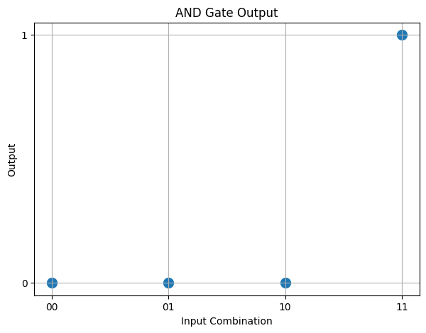
Part C
OR Gate Derivation
Weights: w1 = 1, w2 = 1
Threshold = 1
Weighted sum = x1(1) + x2(1)
Output = 1 when weighted sum >= 1
Output = 0 when weighted sum < 1

OR Gate Truth Table
Input1 Input2 Weighted Sum Output
0 0 0 0
0 1 1 1
1 0 1 1
1 1 2 1
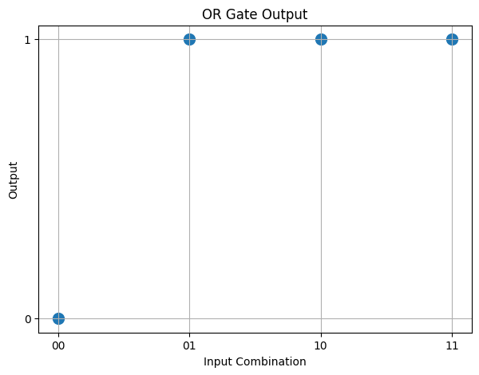
Part D
NOT Gate Derivation
Weight: w1 = -1
Threshold = 0
Weighted sum = x1(-1)
Output = 1 when weighted sum >= 0
Output = 0 when weighted sum < 0

NOT Gate Truth Table
Input Weighted Sum Output
0 0 1
1 -1 0
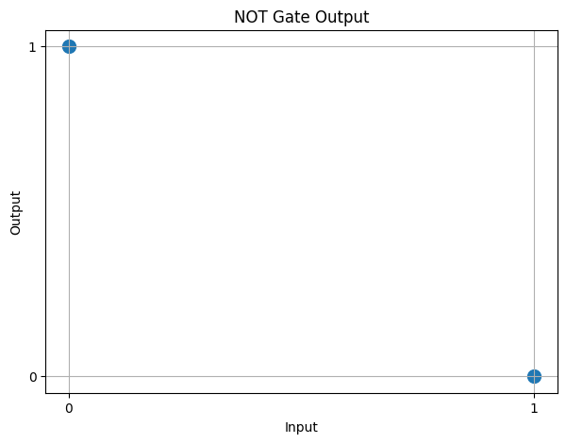
Part E
3-Input AND Gate Derivation
Weights: w1 = 1, w2 = 1, w3 = 1
Threshold = 3
Weighted sum = x1(1) + x2(1) + x3(1)
Output = 1 when weighted sum >= 3
Output = 0 when weighted sum < 3

3-Input AND Gate Truth Table
Input1 Input2 Input3 Weighted Sum Output
0 0 0 0 0
0 0 1 1 0
0 1 0 1 0
0 1 1 2 0
1 0 0 1 0
1 0 1 2 0
1 1 0 2 0
1 1 1 3 1
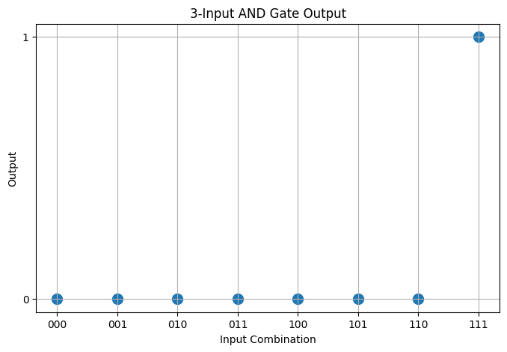
Part F
XOR Gate Using Single M-P Neuron
Weights: w1 = 1, w2 = 1
Threshold = 1
Weighted sum = x1(1) + x2(1)
Output = 1 when weighted sum >= 1
Output = 0 when weighted sum < 1
A single M-P neuron cannot correctly realize XOR

XOR Attempt Truth Table
Input1 Input2 Weighted Sum Output
0 0 0 0
0 1 1 1
1 0 1 1
1 1 2 1
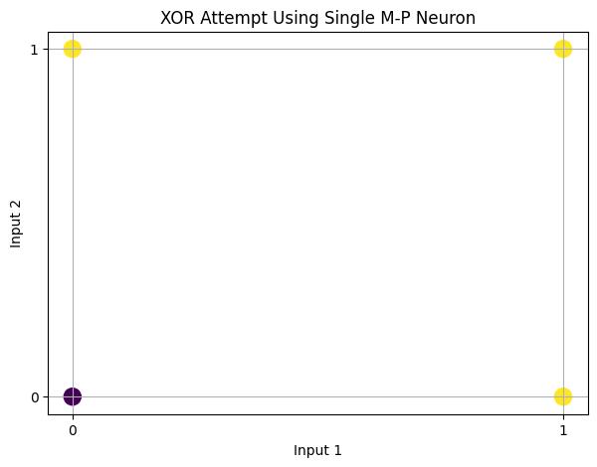
Part G
XOR Threshold Comparison

Threshold = 1
Input1 Input2 Weighted Sum Output
0 0 0 0
0 1 1 1
1 0 1 1
1 1 2 1

Threshold = 2
Input1 Input2 Weighted Sum Output
0 0 0 0
0 1 1 0
1 0 1 0
1 1 2 1
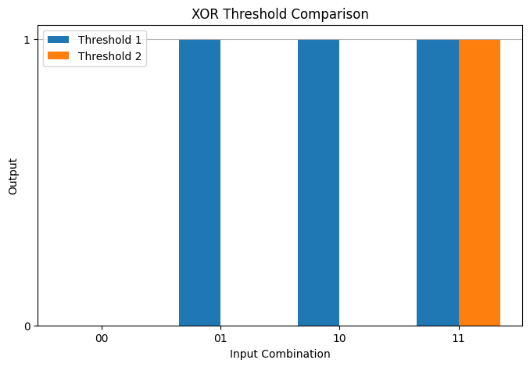
Part H
Final Results
AND Gate: Weights = [1,1], Threshold = 2
OR Gate: Weights = [1,1], Threshold = 1
NOT Gate: Weights = [-1], Threshold = 0
3-Input AND Gate: Weights = [1,1,1], Threshold = 3
XOR Gate: Cannot be realized using a single M-P neuron
XOR requires multiple neurons because it is not linearly separable

Task 2
import numpy as np
import matplotlib.pyplot as plt

print("Part A")
print("Perceptron Class")
class Perceptron:
def __init__(self):
self.weights = None
self.bias = 0
self.error_history = []
def fit(self,X,y,epochs,lr):
self.weights = np.zeros(X.shape[1])
self.bias = 0
self.error_history = []
for epoch in range(epochs):
errors = 0
for i in range(len(X)):
prediction = self.predict(X[i])
error = y[i] - prediction
self.weights += lr * error * X[i]
self.bias += lr * error
if error != 0:
errors += 1
self.error_history.append(errors)
print("Epoch:",epoch + 1)
print("Misclassifications:",errors)
def predict(self,X):
linear_output = np.dot(X,self.weights) + self.bias
prediction = 1 if linear_output >= 0 else 0
return prediction
print("Perceptron class created")

print("\nPart B")
print("AND Truth Table")
X_and = np.array([[0,0],[0,1],[1,0],[1,1]])
y_and = np.array([0,0,0,1])
and_perceptron = Perceptron()
epochs = 20
learning_rate = 0.1
print("Training AND perceptron")
and_perceptron.fit(X_and,y_and,epochs,learning_rate)
and_predictions = np.array([and_perceptron.predict(x) for x in X_and])
print("\nAND Results")
print("Input1 Input2 Actual Predicted")
for i in range(len(X_and)):
print(X_and[i,0],X_and[i,1],y_and[i],and_predictions[i])
print("Final weights:",and_perceptron.weights)
print("Final bias:",and_perceptron.bias)

print("\nPart C")
print("AND Decision Boundary")
x_values = np.linspace(-0.5,1.5,100)
if and_perceptron.weights[1] != 0:
y_values = -(and_perceptron.weights[0] * x_values + and_perceptron.bias) / and_perceptron.weights[1]
plt.figure(figsize=(7,5))
plt.scatter(X_and[y_and == 0,0],X_and[y_and == 0,1],color="red",label="Class 0")
plt.scatter(X_and[y_and == 1,0],X_and[y_and == 1,1],color="blue",label="Class 1")
plt.plot(x_values,y_values,color="black",label="Decision Boundary")
plt.xlabel("Input 1")
plt.ylabel("Input 2")
plt.title("AND Perceptron Decision Boundary")
plt.xlim(-0.5,1.5)
plt.ylim(-0.5,1.5)
plt.legend()
plt.grid()
plt.show()

print("\nPart D")
print("AND Misclassification Curve")
plt.figure(figsize=(7,5))
plt.plot(range(1,epochs + 1),and_perceptron.error_history,marker="o")
plt.xlabel("Epoch")
plt.ylabel("Misclassifications")
plt.title("AND Perceptron Convergence")
plt.grid()
plt.show()

print("\nPart E")
print("OR Truth Table")
X_or = np.array([[0,0],[0,1],[1,0],[1,1]])
y_or = np.array([0,1,1,1])
or_perceptron = Perceptron()
print("Training OR perceptron")
or_perceptron.fit(X_or,y_or,epochs,learning_rate)
or_predictions = np.array([or_perceptron.predict(x) for x in X_or])
print("\nOR Results")
print("Input1 Input2 Actual Predicted")
for i in range(len(X_or)):
print(X_or[i,0],X_or[i,1],y_or[i],or_predictions[i])
print("Final weights:",or_perceptron.weights)
print("Final bias:",or_perceptron.bias)

print("\nPart F")
print("OR Decision Boundary")
x_values = np.linspace(-0.5,1.5,100)
if or_perceptron.weights[1] != 0:
y_values = -(or_perceptron.weights[0] * x_values + or_perceptron.bias) / or_perceptron.weights[1]
plt.figure(figsize=(7,5))
plt.scatter(X_or[y_or == 0,0],X_or[y_or == 0,1],color="red",label="Class 0")
plt.scatter(X_or[y_or == 1,0],X_or[y_or == 1,1],color="blue",label="Class 1")
plt.plot(x_values,y_values,color="black",label="Decision Boundary")
plt.xlabel("Input 1")
plt.ylabel("Input 2")
plt.title("OR Perceptron Decision Boundary")
plt.xlim(-0.5,1.5)
plt.ylim(-0.5,1.5)
plt.legend()
plt.grid()
plt.show()

print("\nPart G")
print("OR Misclassification Curve")
plt.figure(figsize=(7,5))
plt.plot(range(1,epochs + 1),or_perceptron.error_history,marker="o")
plt.xlabel("Epoch")
plt.ylabel("Misclassifications")
plt.title("OR Perceptron Convergence")
plt.grid()
plt.show()

print("\nPart H")
print("XOR Truth Table")
X_xor = np.array([[0,0],[0,1],[1,0],[1,1]])
y_xor = np.array([0,1,1,0])
xor_perceptron = Perceptron()
print("Training XOR perceptron")
xor_perceptron.fit(X_xor,y_xor,epochs,learning_rate)
xor_predictions = np.array([xor_perceptron.predict(x) for x in X_xor])
print("\nXOR Results")
print("Input1 Input2 Actual Predicted")
for i in range(len(X_xor)):
print(X_xor[i,0],X_xor[i,1],y_xor[i],xor_predictions[i])
print("Final weights:",xor_perceptron.weights)
print("Final bias:",xor_perceptron.bias)

print("\nPart I")
print("XOR Misclassification Curve")
plt.figure(figsize=(7,5))
plt.plot(range(1,epochs + 1),xor_perceptron.error_history,marker="o")
plt.xlabel("Epoch")
plt.ylabel("Misclassifications")
plt.title("XOR Perceptron Error Curve")
plt.grid()
plt.show()

print("\nPart J")
print("XOR Linear Separability")
print("XOR requires the following outputs:")
print("Input 00 -> Output 0")
print("Input 01 -> Output 1")
print("Input 10 -> Output 1")
print("Input 11 -> Output 0")
print("The two Class 1 points are diagonally opposite")
print("The two Class 0 points are also diagonally opposite")
print("No single straight line can separate the two classes")
print("Therefore XOR is not linearly separable")
print("A single perceptron cannot learn XOR")
plt.figure(figsize=(7,5))
plt.scatter(X_xor[y_xor == 0,0],X_xor[y_xor == 0,1],color="red",s=150,label="Class 0")
plt.scatter(X_xor[y_xor == 1,0],X_xor[y_xor == 1,1],color="blue",s=150,label="Class 1")
plt.xlabel("Input 1")
plt.ylabel("Input 2")
plt.title("XOR Linear Separability")
plt.xticks([0,1])
plt.yticks([0,1])
plt.legend()
plt.grid()
plt.show()

print("\nPart K")
print("Final Comparison")
and_final_error = and_perceptron.error_history[-1]
or_final_error = or_perceptron.error_history[-1]
xor_final_error = xor_perceptron.error_history[-1]
print("AND final misclassifications:",and_final_error)
print("OR final misclassifications:",or_final_error)
print("XOR final misclassifications:",xor_final_error)
plt.figure(figsize=(8,5))
plt.plot(range(1,epochs + 1),and_perceptron.error_history,marker="o",label="AND")
plt.plot(range(1,epochs + 1),or_perceptron.error_history,marker="s",label="OR")
plt.plot(range(1,epochs + 1),xor_perceptron.error_history,marker="^",label="XOR")
plt.xlabel("Epoch")
plt.ylabel("Misclassifications")
plt.title("Perceptron Convergence Comparison")
plt.legend()
plt.grid()
plt.show()

Output
Part A
Perceptron Class
Perceptron class created

Part B
AND Truth Table
Training AND perceptron
Epoch: 1
Misclassifications: 2
Epoch: 2
Misclassifications: 3
Epoch: 3
Misclassifications: 3
Epoch: 4
Misclassifications: 0
Epoch: 5
Misclassifications: 0
Epoch: 6
Misclassifications: 0
Epoch: 7
Misclassifications: 0
Epoch: 8
Misclassifications: 0
Epoch: 9
Misclassifications: 0
Epoch: 10
Misclassifications: 0
Epoch: 11
Misclassifications: 0
Epoch: 12
Misclassifications: 0
Epoch: 13
Misclassifications: 0
Epoch: 14
Misclassifications: 0
Epoch: 15
Misclassifications: 0
Epoch: 16
Misclassifications: 0
Epoch: 17
Misclassifications: 0
Epoch: 18
Misclassifications: 0
Epoch: 19
Misclassifications: 0
Epoch: 20
Misclassifications: 0

AND Results
Input1 Input2 Actual Predicted
0 0 0 0
0 1 0 0
1 0 0 0
1 1 1 1
Final weights: [0.2 0.1]
Final bias: -0.20000000000000004

Part C
AND Decision Boundary
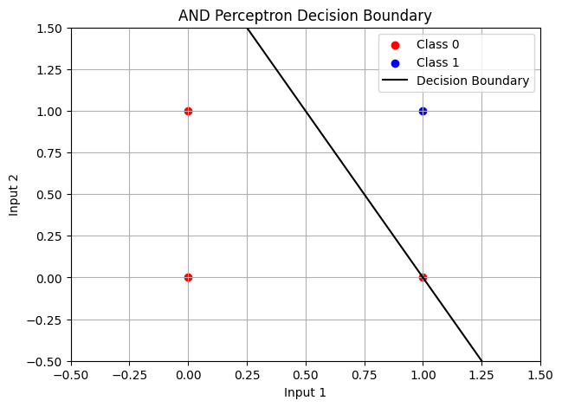
Part D
AND Misclassification Curve
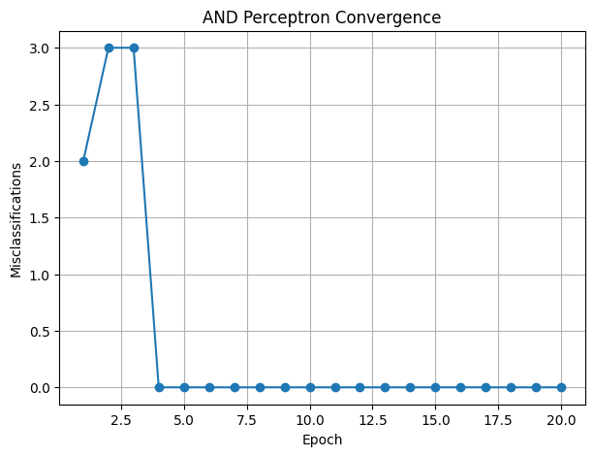
Part E
OR Truth Table
Training OR perceptron
Epoch: 1
Misclassifications: 2
Epoch: 2
Misclassifications: 2
Epoch: 3
Misclassifications: 1
Epoch: 4
Misclassifications: 0
Epoch: 5
Misclassifications: 0
Epoch: 6
Misclassifications: 0
Epoch: 7
Misclassifications: 0
Epoch: 8
Misclassifications: 0
Epoch: 9
Misclassifications: 0
Epoch: 10
Misclassifications: 0
Epoch: 11
Misclassifications: 0
Epoch: 12
Misclassifications: 0
Epoch: 13
Misclassifications: 0
Epoch: 14
Misclassifications: 0
Epoch: 15
Misclassifications: 0
Epoch: 16
Misclassifications: 0
Epoch: 17
Misclassifications: 0
Epoch: 18
Misclassifications: 0
Epoch: 19
Misclassifications: 0
Epoch: 20
Misclassifications: 0

OR Results
Input1 Input2 Actual Predicted
0 0 0 0
0 1 1 1
1 0 1 1
1 1 1 1
Final weights: [0.1 0.1]
Final bias: -0.1

Part F
OR Decision Boundary
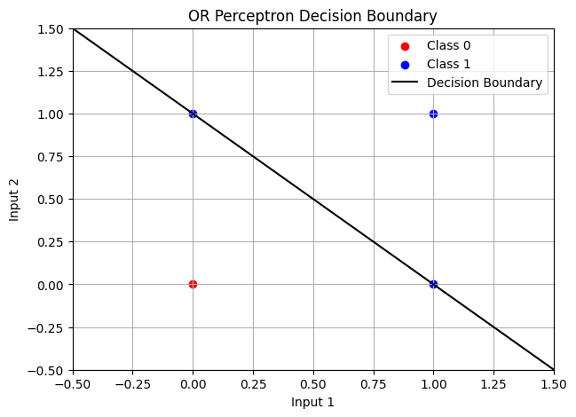
Part G
OR Misclassification Curve
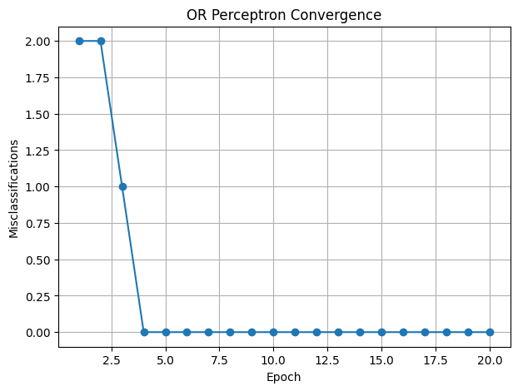
Part H
XOR Truth Table
Training XOR perceptron
Epoch: 1
Misclassifications: 3
Epoch: 2
Misclassifications: 3
Epoch: 3
Misclassifications: 4
Epoch: 4
Misclassifications: 4
Epoch: 5
Misclassifications: 4
Epoch: 6
Misclassifications: 4
Epoch: 7
Misclassifications: 4
Epoch: 8
Misclassifications: 4
Epoch: 9
Misclassifications: 4
Epoch: 10
Misclassifications: 4
Epoch: 11
Misclassifications: 4
Epoch: 12
Misclassifications: 4
Epoch: 13
Misclassifications: 4
Epoch: 14
Misclassifications: 4
Epoch: 15
Misclassifications: 4
Epoch: 16
Misclassifications: 4
Epoch: 17
Misclassifications: 4
Epoch: 18
Misclassifications: 4
Epoch: 19
Misclassifications: 4
Epoch: 20
Misclassifications: 4

XOR Results
Input1 Input2 Actual Predicted
0 0 0 1
0 1 1 1
1 0 1 0
1 1 0 0
Final weights: [-0.1 0. ]
Final bias: 0.0

Part I
XOR Misclassification Curve
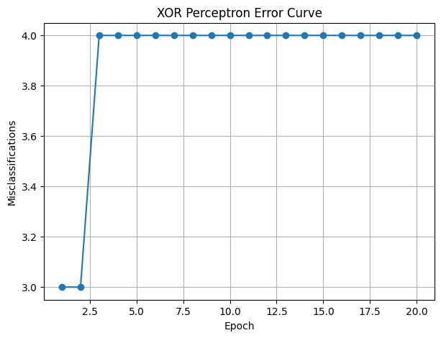
Part J
XOR Linear Separability
XOR requires the following outputs:
Input 00 -> Output 0
Input 01 -> Output 1
Input 10 -> Output 1
Input 11 -> Output 0
The two Class 1 points are diagonally opposite
The two Class 0 points are also diagonally opposite
No single straight line can separate the two classes
Therefore XOR is not linearly separable
A single perceptron cannot learn XOR
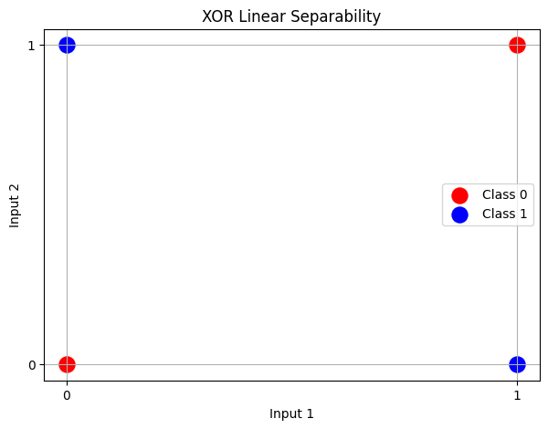
Part K
Final Comparison
AND final misclassifications: 0
OR final misclassifications: 0
XOR final misclassifications: 4
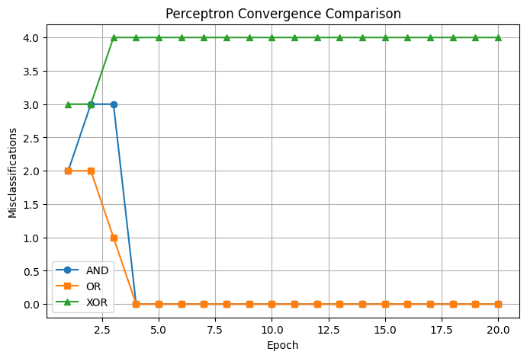

Task 3
import numpy as np
import matplotlib.pyplot as plt

print("Part A")
print("2-Layer MLP From Scratch")
print("Input Layer -> Hidden Layer -> Output Layer")
print("Hidden activation: Sigmoid")
print("Output activation: Sigmoid")
print("No deep learning framework is used")
X = np.array([[0,0],[0,1],[1,0],[1,1]])
y = np.array([[0],[1],[1],[0]])
print("Input shape:",X.shape)
print("Target shape:",y.shape)
def sigmoid(x):
return 1 / (1 + np.exp(-x))
def sigmoid_derivative(x):
return x * (1 - x)
print("Sigmoid function created")
print("Sigmoid derivative function created")

print("\nPart B")
print("Forward Propagation and Backpropagation")
class MLP:
def __init__(self,input_size,hidden_size,output_size,learning_rate):
self.hidden_size = hidden_size
self.learning_rate = learning_rate
self.weights_input_hidden = np.random.randn(input_size,hidden_size) * 0.5
self.bias_hidden = np.zeros((1,hidden_size))
self.weights_hidden_output = np.random.randn(hidden_size,output_size) * 0.5
self.bias_output = np.zeros((1,output_size))
self.loss_history = []
def forward(self,X):
self.hidden_input = np.dot(X,self.weights_input_hidden) + self.bias_hidden
self.hidden_output = sigmoid(self.hidden_input)
self.output_input = np.dot(self.hidden_output,self.weights_hidden_output) + self.bias_output
self.output = sigmoid(self.output_input)
return self.output
def backward(self,X,y):
samples = len(X)
output_error = self.output - y
output_delta = output_error * sigmoid_derivative(self.output)
hidden_error = np.dot(output_delta,self.weights_hidden_output.T)
hidden_delta = hidden_error * sigmoid_derivative(self.hidden_output)
gradient_weights_hidden_output = np.dot(self.hidden_output.T,output_delta) / samples
gradient_bias_output = np.sum(output_delta,axis=0,keepdims=True) / samples
gradient_weights_input_hidden = np.dot(X.T,hidden_delta) / samples
gradient_bias_hidden = np.sum(hidden_delta,axis=0,keepdims=True) / samples
self.weights_hidden_output -= self.learning_rate * gradient_weights_hidden_output
self.bias_output -= self.learning_rate * gradient_bias_output
self.weights_input_hidden -= self.learning_rate * gradient_weights_input_hidden
self.bias_hidden -= self.learning_rate * gradient_bias_hidden
def fit(self,X,y,epochs):
self.loss_history = []
for epoch in range(epochs):
predictions = self.forward(X)
loss = np.mean((y - predictions) ** 2)
self.loss_history.append(loss)
self.backward(X,y)
if epoch == 0 or (epoch + 1) % 1000 == 0:
print("Epoch:",epoch + 1,"Loss:",loss)
if loss < 0.001:
print("Converged at epoch:",epoch + 1)
break
def predict(self,X):
predictions = self.forward(X)
return np.where(predictions >= 0.5,1,0)
print("MLP class created")

print("\nPart C")
print("Training MLP on XOR")
np.random.seed(42)
hidden_neurons = 2
learning_rate = 1.0
epochs = 20000
mlp = MLP(2,hidden_neurons,1,learning_rate)
print("Hidden neurons:",hidden_neurons)
print("Learning rate:",learning_rate)
print("Maximum epochs:",epochs)
mlp.fit(X,y,epochs)
predictions = mlp.predict(X)
final_outputs = mlp.forward(X)
print("\nXOR Results")
print("Input1 Input2 Actual Output Prediction")
for i in range(len(X)):
print(X[i,0],X[i,1],y[i,0],round(final_outputs[i,0],4),predictions[i,0])
final_loss = np.mean((y - final_outputs) ** 2)
print("Final loss:",final_loss)
print("Final weights input-hidden:")
print(mlp.weights_input_hidden)
print("Final bias hidden:")
print(mlp.bias_hidden)
print("Final weights hidden-output:")
print(mlp.weights_hidden_output)
print("Final bias output:")
print(mlp.bias_output)

print("\nPart D")
print("XOR Loss Curve")
plt.figure(figsize=(8,5))
plt.plot(range(1,len(mlp.loss_history) + 1),mlp.loss_history)
plt.xlabel("Epoch")
plt.ylabel("Mean Squared Error")
plt.title("MLP XOR Loss")
plt.grid()
plt.show()

print("\nPart E")
print("Learned XOR Decision Boundary")
x_min = -0.5
x_max = 1.5
y_min = -0.5
y_max = 1.5
x_values = np.linspace(x_min,x_max,200)
y_values = np.linspace(y_min,y_max,200)
xx,yy = np.meshgrid(x_values,y_values)
grid = np.c_[xx.ravel(),yy.ravel()]
grid_output = mlp.forward(grid)
grid_output = grid_output.reshape(xx.shape)
plt.figure(figsize=(8,6))
plt.contourf(xx,yy,grid_output,levels=[0,0.5,1],alpha=0.3)
plt.contour(xx,yy,grid_output,levels=[0.5],colors="black")
plt.scatter(X[y[:,0] == 0,0],X[y[:,0] == 0,1],color="red",s=150,label="Class 0")
plt.scatter(X[y[:,0] == 1,0],X[y[:,0] == 1,1],color="blue",s=150,label="Class 1")
plt.xlabel("Input 1")
plt.ylabel("Input 2")
plt.title("MLP Learned XOR Decision Boundary")
plt.xlim(-0.5,1.5)
plt.ylim(-0.5,1.5)
plt.legend()
plt.grid()
plt.show()

print("\nPart F")
print("Hidden Neurons Experiment")
hidden_neurons_list = [2,4,8]
learning_rate_experiment = 1.0
experiment_results = []
for hidden_neurons in hidden_neurons_list:
np.random.seed(42)
model = MLP(2,hidden_neurons,1,learning_rate_experiment)
model.fit(X,y,20000)
final_loss = model.loss_history[-1]
epochs_needed = len(model.loss_history)
experiment_results.append([hidden_neurons,learning_rate_experiment,epochs_needed,final_loss])
print("Hidden neurons:",hidden_neurons)
print("Learning rate:",learning_rate_experiment)
print("Epochs needed:",epochs_needed)
print("Final loss:",final_loss)

print("\nPart G")
print("Learning Rate Experiment")
hidden_neurons_experiment = 4
learning_rates = [0.01,0.1,1.0]
for learning_rate in learning_rates:
np.random.seed(42)
model = MLP(2,hidden_neurons_experiment,1,learning_rate)
model.fit(X,y,100000)
final_loss = model.loss_history[-1]
epochs_needed = len(model.loss_history)
experiment_results.append([hidden_neurons_experiment,learning_rate,epochs_needed,final_loss])
print("Hidden neurons:",hidden_neurons_experiment)
print("Learning rate:",learning_rate)
print("Epochs needed:",epochs_needed)
print("Final loss:",final_loss)

print("\nPart H")
print("Hidden Neurons and Learning Rate Comparison")
print("Hidden Neurons Learning Rate Epochs Final Loss")
for result in experiment_results:
print(result[0],result[1],result[2],result[3])

print("\nPart I")
print("Complete Configuration Table")
print("Configuration Hidden Neurons Learning Rate Epochs Final Loss")
for i,result in enumerate(experiment_results):
print(i + 1,result[0],result[1],result[2],result[3])

print("\nPart J")
print("Experiment Visualization")
configuration_names = []
epoch_values = []
for i,result in enumerate(experiment_results):
configuration_names.append(str(result[0]) + "-" + str(result[1]))
epoch_values.append(result[2])
plt.figure(figsize=(10,5))
plt.bar(configuration_names,epoch_values)
plt.xlabel("Hidden Neurons - Learning Rate")
plt.ylabel("Epochs to Converge")
plt.title("MLP XOR Convergence Comparison")
plt.grid(axis="y")
plt.show()

print("\nPart K")
print("Final Conclusion")
print("A single perceptron cannot solve XOR because XOR is not linearly separable")
print("The 2-layer MLP uses a hidden layer to learn a nonlinear decision boundary")
print("The sigmoid activation function provides the required nonlinearity")
print("The MLP can correctly classify the four XOR inputs")
print("Increasing hidden neurons changes the learning behavior")
print("Changing the learning rate changes the speed of convergence")

Output
Part A
2-Layer MLP From Scratch
Input Layer -> Hidden Layer -> Output Layer
Hidden activation: Sigmoid
Output activation: Sigmoid
No deep learning framework is used
Input shape: (4, 2)
Target shape: (4, 1)
Sigmoid function created
Sigmoid derivative function created

Part B
Forward Propagation and Backpropagation
MLP class created

Part C
Training MLP on XOR
Hidden neurons: 2
Learning rate: 1.0
Maximum epochs: 20000
Epoch: 1 Loss: 0.25115581219599126
Epoch: 1000 Loss: 0.24997190971425712
Epoch: 2000 Loss: 0.24984862354276832
Epoch: 3000 Loss: 0.2472056902073442
Epoch: 4000 Loss: 0.151494807491308
Epoch: 5000 Loss: 0.13207542283319695
Epoch: 6000 Loss: 0.1288114251068722
Epoch: 7000 Loss: 0.12756626488140937
Epoch: 8000 Loss: 0.12692116065670084
Epoch: 9000 Loss: 0.1265296221559854
Epoch: 10000 Loss: 0.1262678081253532
Epoch: 11000 Loss: 0.12608089775824302
Epoch: 12000 Loss: 0.12594101487089304
Epoch: 13000 Loss: 0.1258325301367338
Epoch: 14000 Loss: 0.12574601958917006
Epoch: 15000 Loss: 0.12567547151465244
Epoch: 16000 Loss: 0.12561687450315318
Epoch: 17000 Loss: 0.12556745166075056
Epoch: 18000 Loss: 0.12552522093041837
Epoch: 19000 Loss: 0.1254887304707445
Epoch: 20000 Loss: 0.12545689295232004

XOR Results
Input1 Input2 Actual Output Prediction
0 0 0 0.0185 0
0 1 1 0.4993 0
1 0 1 0.9832 1
1 1 0 0.5005 1
Final loss: 0.12545686314905408
Final weights input-hidden:
[[ 3.6937647 -4.08277421]
[ 8.63216435 8.79083721]]
Final bias hidden:
[[-0.86054285 3.14649902]]
Final weights hidden-output:
[[ 6.00966848]
[-6.12881185]]
Final bias output:
[[0.11884991]]

Part D
XOR Loss Curve
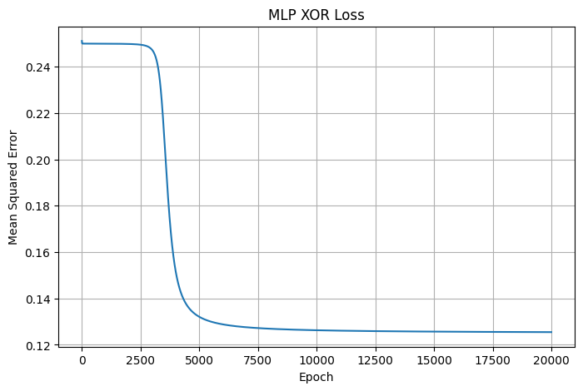
Part E
Learned XOR Decision Boundary
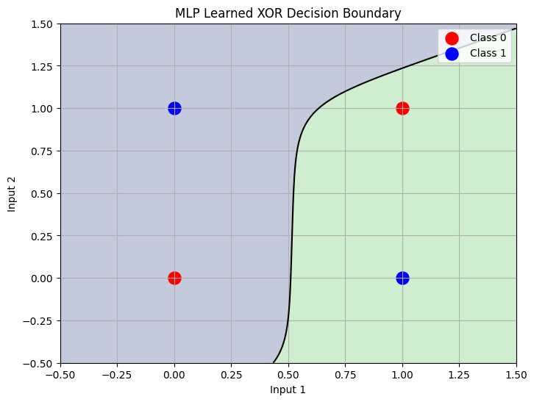
Part F
Hidden Neurons Experiment
Epoch: 1 Loss: 0.25115581219599126
Epoch: 1000 Loss: 0.24997190971425712
Epoch: 2000 Loss: 0.24984862354276832
Epoch: 3000 Loss: 0.2472056902073442
Epoch: 4000 Loss: 0.151494807491308
Epoch: 5000 Loss: 0.13207542283319695
Epoch: 6000 Loss: 0.1288114251068722
Epoch: 7000 Loss: 0.12756626488140937
Epoch: 8000 Loss: 0.12692116065670084
Epoch: 9000 Loss: 0.1265296221559854
Epoch: 10000 Loss: 0.1262678081253532
Epoch: 11000 Loss: 0.12608089775824302
Epoch: 12000 Loss: 0.12594101487089304
Epoch: 13000 Loss: 0.1258325301367338
Epoch: 14000 Loss: 0.12574601958917006
Epoch: 15000 Loss: 0.12567547151465244
Epoch: 16000 Loss: 0.12561687450315318
Epoch: 17000 Loss: 0.12556745166075056
Epoch: 18000 Loss: 0.12552522093041837
Epoch: 19000 Loss: 0.1254887304707445
Epoch: 20000 Loss: 0.12545689295232004
Hidden neurons: 2
Learning rate: 1.0
Epochs needed: 20000
Final loss: 0.12545689295232004
Epoch: 1 Loss: 0.2556753002334093
Epoch: 1000 Loss: 0.24966091652145478
Epoch: 2000 Loss: 0.20300835027197578
Epoch: 3000 Loss: 0.022808797066906847
Epoch: 4000 Loss: 0.005203951404939698
Epoch: 5000 Loss: 0.0026630536303743173
Epoch: 6000 Loss: 0.001742223818237483
Epoch: 7000 Loss: 0.0012795864309558592
Epoch: 8000 Loss: 0.0010047487199429965
Converged at epoch: 8022
Hidden neurons: 4
Learning rate: 1.0
Epochs needed: 8022
Final loss: 0.0009999663546458228
Epoch: 1 Loss: 0.2876340734600314
Epoch: 1000 Loss: 0.15997527125788913
Epoch: 2000 Loss: 0.009192739123368012
Epoch: 3000 Loss: 0.003563286262208195
Epoch: 4000 Loss: 0.002121516549329777
Epoch: 5000 Loss: 0.001487928309606509
Epoch: 6000 Loss: 0.0011371011348290999
Converged at epoch: 6571
Hidden neurons: 8
Learning rate: 1.0
Epochs needed: 6571
Final loss: 0.0009998876259531666

Part G
Learning Rate Experiment
Epoch: 1 Loss: 0.2556753002334093
Epoch: 1000 Loss: 0.25066820030842807
Epoch: 2000 Loss: 0.2503644663644882
Epoch: 3000 Loss: 0.2503328555346355
Epoch: 4000 Loss: 0.25031698384008105
Epoch: 5000 Loss: 0.2503025937628845
Epoch: 6000 Loss: 0.25028886015215945
Epoch: 7000 Loss: 0.25027570436661917
Epoch: 8000 Loss: 0.2502630910757208
Epoch: 9000 Loss: 0.2502509892530974
Epoch: 10000 Loss: 0.250239369918353
Epoch: 11000 Loss: 0.25022820589110406
Epoch: 12000 Loss: 0.25021747165729785
Epoch: 13000 Loss: 0.25020714324914134
Epoch: 14000 Loss: 0.2501971981341522
Epoch: 15000 Loss: 0.25018761511273535
Epoch: 16000 Loss: 0.25017837422364353
Epoch: 17000 Loss: 0.250169456656673
Epoch: 18000 Loss: 0.25016084467198413
Epoch: 19000 Loss: 0.25015252152548517
Epoch: 20000 Loss: 0.2501444713997733
Epoch: 21000 Loss: 0.25013667934016426
Epoch: 22000 Loss: 0.2501291311953891
Epoch: 23000 Loss: 0.25012181356257196
Epoch: 24000 Loss: 0.2501147137361347
Epoch: 25000 Loss: 0.25010781966030754
Epoch: 26000 Loss: 0.2501011198849511
Epoch: 27000 Loss: 0.2500946035244202
Epoch: 28000 Loss: 0.2500882602192222
Epoch: 29000 Loss: 0.25008208010024596
Epoch: 30000 Loss: 0.2500760537553508
Epoch: 31000 Loss: 0.25007017219812844
Epoch: 32000 Loss: 0.2500644268386599
Epoch: 33000 Loss: 0.25005880945610937
Epoch: 34000 Loss: 0.250053312173003
Epoch: 35000 Loss: 0.25004792743105997
Epoch: 36000 Loss: 0.2500426479684463
Epoch: 37000 Loss: 0.2500374667983358
Epoch: 38000 Loss: 0.2500323771886699
Epoch: 39000 Loss: 0.25002737264301594
Epoch: 40000 Loss: 0.25002244688243014
Epoch: 41000 Loss: 0.25001759382823924
Epoch: 42000 Loss: 0.25001280758565836
Epoch: 43000 Loss: 0.2500080824281706
Epoch: 44000 Loss: 0.2500034127825958
Epoch: 45000 Loss: 0.2499987932147831
Epoch: 46000 Loss: 0.24999421841586217
Epoch: 47000 Loss: 0.24998968318899512
Epoch: 48000 Loss: 0.24998518243657125
Epoch: 49000 Loss: 0.2499807111477903
Epoch: 50000 Loss: 0.24997626438658332
Epoch: 51000 Loss: 0.24997183727981986
Epoch: 52000 Loss: 0.24996742500575456
Epoch: 53000 Loss: 0.24996302278266413
Epoch: 54000 Loss: 0.24995862585763234
Epoch: 55000 Loss: 0.24995422949543367
Epoch: 56000 Loss: 0.24994982896747445
Epoch: 57000 Loss: 0.2499454195407463
Epoch: 58000 Loss: 0.24994099646674658
Epoch: 59000 Loss: 0.2499365549703233
Epoch: 60000 Loss: 0.24993209023839758
Epoch: 61000 Loss: 0.2499275974085206
Epoch: 62000 Loss: 0.24992307155721516
Epoch: 63000 Loss: 0.24991850768805646
Epoch: 64000 Loss: 0.2499139007194413
Epoch: 65000 Loss: 0.249909245471995
Epoch: 66000 Loss: 0.249904536655561
Epoch: 67000 Loss: 0.2498997688557194
Epoch: 68000 Loss: 0.24989493651977274
Epoch: 69000 Loss: 0.2498900339421386
Epoch: 70000 Loss: 0.24988505524908317
Epoch: 71000 Loss: 0.24987999438272485
Epoch: 72000 Loss: 0.24987484508423427
Epoch: 73000 Loss: 0.24986960087615184
Epoch: 74000 Loss: 0.24986425504373733
Epoch: 75000 Loss: 0.24985880061526056
Epoch: 76000 Loss: 0.24985323034113746
Epoch: 77000 Loss: 0.24984753667180448
Epoch: 78000 Loss: 0.2498417117342206
Epoch: 79000 Loss: 0.24983574730687486
Epoch: 80000 Loss: 0.2498296347931681
Epoch: 81000 Loss: 0.24982336519302853
Epoch: 82000 Loss: 0.24981692907260733
Epoch: 83000 Loss: 0.2498103165318895
Epoch: 84000 Loss: 0.24980351717004073
Epoch: 85000 Loss: 0.24979652004829767
Epoch: 86000 Loss: 0.24978931365018886
Epoch: 87000 Loss: 0.24978188583886235
Epoch: 88000 Loss: 0.2497742238112696
Epoch: 89000 Loss: 0.24976631404894067
Epoch: 90000 Loss: 0.2497581422650575
Epoch: 91000 Loss: 0.2497496933475119
Epoch: 92000 Loss: 0.24974095129760482
Epoch: 93000 Loss: 0.24973189916401556
Epoch: 94000 Loss: 0.249722518971637
Epoch: 95000 Loss: 0.24971279164484045
Epoch: 96000 Loss: 0.24970269692469427
Epoch: 97000 Loss: 0.24969221327962074
Epoch: 98000 Loss: 0.2496813178089346
Epoch: 99000 Loss: 0.24966998613865565
Epoch: 100000 Loss: 0.24965819230894193
Hidden neurons: 4
Learning rate: 0.01
Epochs needed: 100000
Final loss: 0.24965819230894193
Epoch: 1 Loss: 0.2556753002334093
Epoch: 1000 Loss: 0.25023945568631056
Epoch: 2000 Loss: 0.2501445286408644
Epoch: 3000 Loss: 0.2500760984766407
Epoch: 4000 Loss: 0.2500224884830861
Epoch: 5000 Loss: 0.2499763096756522
Epoch: 6000 Loss: 0.24993214574003192
Epoch: 7000 Loss: 0.24988512913310765
Epoch: 8000 Loss: 0.24982973939696526
Epoch: 9000 Loss: 0.24975829851742065
Epoch: 10000 Loss: 0.24965843867996973
Epoch: 11000 Loss: 0.24950812596886643
Epoch: 12000 Loss: 0.24926513799165267
Epoch: 13000 Loss: 0.24884429642943134
Epoch: 14000 Loss: 0.24807019009810582
Epoch: 15000 Loss: 0.24659406064373385
Epoch: 16000 Loss: 0.2438000249630355
Epoch: 17000 Loss: 0.2387867608272294
Epoch: 18000 Loss: 0.23047452114035505
Epoch: 19000 Loss: 0.2181026385552845
Epoch: 20000 Loss: 0.20244207881710127
Epoch: 21000 Loss: 0.18544680055202256
Epoch: 22000 Loss: 0.167654487312181
Epoch: 23000 Loss: 0.1477006700994246
Epoch: 24000 Loss: 0.12449870625319148
Epoch: 25000 Loss: 0.09938336342641871
Epoch: 26000 Loss: 0.07530156223919188
Epoch: 27000 Loss: 0.0549754481618325
Epoch: 28000 Loss: 0.03986477021557126
Epoch: 29000 Loss: 0.029530765084742706
Epoch: 30000 Loss: 0.022611967543823816
Epoch: 31000 Loss: 0.017898856981813184
Epoch: 32000 Loss: 0.014585934820654935
Epoch: 33000 Loss: 0.01217847805197362
Epoch: 34000 Loss: 0.010374482253483475
Epoch: 35000 Loss: 0.00898570713236533
Epoch: 36000 Loss: 0.007891343625111747
Epoch: 37000 Loss: 0.007011466258918873
Epoch: 38000 Loss: 0.0062916494041485565
Epoch: 39000 Loss: 0.005693839154164351
Epoch: 40000 Loss: 0.005190786596943314
Epoch: 41000 Loss: 0.004762558052304826
Epoch: 42000 Loss: 0.004394289035045197
Epoch: 43000 Loss: 0.004074702840419109
Epoch: 44000 Loss: 0.003795111161514811
Epoch: 45000 Loss: 0.0035487258150745365
Epoch: 46000 Loss: 0.003330175682485553
Epoch: 47000 Loss: 0.00313516176510574
Epoch: 48000 Loss: 0.0029602069315072697
Epoch: 49000 Loss: 0.0028024717034977943
Epoch: 50000 Loss: 0.0026596168286051477
Epoch: 51000 Loss: 0.002529699484635557
Epoch: 52000 Loss: 0.0024110939876526467
Epoch: 53000 Loss: 0.002302430576384659
Epoch: 54000 Loss: 0.0022025476870594
Epoch: 55000 Loss: 0.002110454405178634
Epoch: 56000 Loss: 0.002025300672102329
Epoch: 57000 Loss: 0.001946353456501467
Epoch: 58000 Loss: 0.0018729775543670378
Epoch: 59000 Loss: 0.0018046200103473183
Epoch: 60000 Loss: 0.0017407973943786997
Epoch: 61000 Loss: 0.001681085346070868
Epoch: 62000 Loss: 0.0016251099326081556
Epoch: 63000 Loss: 0.001572540466339863
Epoch: 64000 Loss: 0.0015230835044815745
Epoch: 65000 Loss: 0.0014764778117006656
Epoch: 66000 Loss: 0.0014324901113370256
Epoch: 67000 Loss: 0.0013909114859204893
Epoch: 68000 Loss: 0.001351554314921999
Epoch: 69000 Loss: 0.0013142496591172642
Epoch: 70000 Loss: 0.0012788450178999454
Epoch: 71000 Loss: 0.0012452023993675745
Epoch: 72000 Loss: 0.0012131966537881763
Epoch: 73000 Loss: 0.0011827140297236117
Epoch: 74000 Loss: 0.0011536509190870179
Epoch: 75000 Loss: 0.0011259127630939578
Epoch: 76000 Loss: 0.001099413095698579
Epoch: 77000 Loss: 0.0010740727048991108
Epoch: 78000 Loss: 0.0010498188954147884
Epoch: 79000 Loss: 0.0010265848388099133
Epoch: 80000 Loss: 0.0010043089992740274
Converged at epoch: 80199
Hidden neurons: 4
Learning rate: 0.1
Epochs needed: 80199
Final loss: 0.0009999853816548266
Epoch: 1 Loss: 0.2556753002334093
Epoch: 1000 Loss: 0.24966091652145478
Epoch: 2000 Loss: 0.20300835027197578
Epoch: 3000 Loss: 0.022808797066906847
Epoch: 4000 Loss: 0.005203951404939698
Epoch: 5000 Loss: 0.0026630536303743173
Epoch: 6000 Loss: 0.001742223818237483
Epoch: 7000 Loss: 0.0012795864309558592
Epoch: 8000 Loss: 0.0010047487199429965
Converged at epoch: 8022
Hidden neurons: 4
Learning rate: 1.0
Epochs needed: 8022
Final loss: 0.0009999663546458228

Part H
Hidden Neurons and Learning Rate Comparison
Hidden Neurons Learning Rate Epochs Final Loss
2 1.0 20000 0.12545689295232004
4 1.0 8022 0.0009999663546458228
8 1.0 6571 0.0009998876259531666
4 0.01 100000 0.24965819230894193
4 0.1 80199 0.0009999853816548266
4 1.0 8022 0.0009999663546458228

Part I
Complete Configuration Table
Configuration Hidden Neurons Learning Rate Epochs Final Loss
1 2 1.0 20000 0.12545689295232004
2 4 1.0 8022 0.0009999663546458228
3 8 1.0 6571 0.0009998876259531666
4 4 0.01 100000 0.24965819230894193
5 4 0.1 80199 0.0009999853816548266
6 4 1.0 8022 0.0009999663546458228

Part J
Experiment Visualization
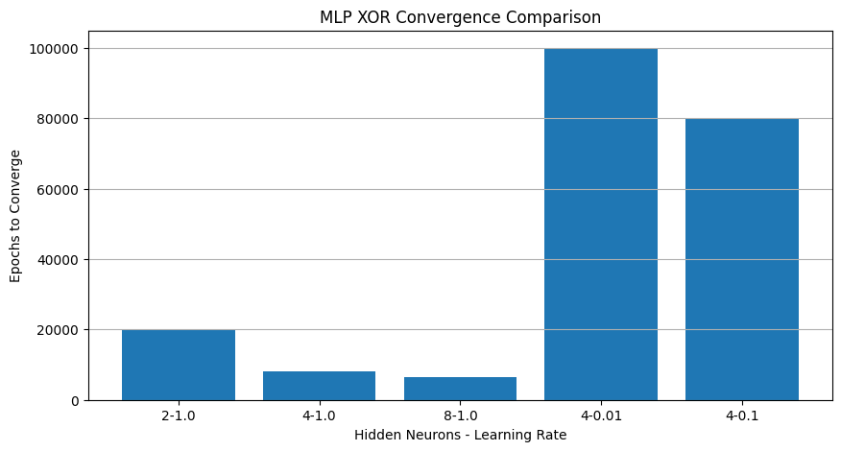
Part K
Final Conclusion
A single perceptron cannot solve XOR because XOR is not linearly separable
The 2-layer MLP uses a hidden layer to learn a nonlinear decision boundary
The sigmoid activation function provides the required nonlinearity
The MLP can correctly classify the four XOR inputs
Increasing hidden neurons changes the learning behavior
Changing the learning rate changes the speed of convergence

Task 4
import numpy as np
import matplotlib.pyplot as plt

print("Part A")
print("MLP Initialization Schemes")
X = np.array([[0,0],[0,1],[1,0],[1,1]])
y = np.array([[0],[1],[1],[0]])
def sigmoid(x):
return 1 / (1 + np.exp(-x))
def sigmoid_derivative(x):
return x * (1 - x)
class MLP:
def __init__(self,input_size,hidden_size,output_size,learning_rate,init_method):
self.hidden_size = hidden_size
self.learning_rate = learning_rate
self.init_method = init_method
self.initialize_weights(input_size,hidden_size,output_size)
def initialize_weights(self,input_size,hidden_size,output_size):
if self.init_method == "zero":
self.weights_input_hidden = np.zeros((input_size,hidden_size))
self.bias_hidden = np.zeros((1,hidden_size))
self.weights_hidden_output = np.zeros((hidden_size,output_size))
self.bias_output = np.zeros((1,output_size))
elif self.init_method == "random":
self.weights_input_hidden = np.random.randn(input_size,hidden_size) * 0.5
self.bias_hidden = np.zeros((1,hidden_size))
self.weights_hidden_output = np.random.randn(hidden_size,output_size) * 0.5
self.bias_output = np.zeros((1,output_size))
elif self.init_method == "xavier":
limit = np.sqrt(6 / (input_size + hidden_size))
self.weights_input_hidden = np.random.uniform(-limit,limit,(input_size,hidden_size))
limit = np.sqrt(6 / (hidden_size + output_size))
self.weights_hidden_output = np.random.uniform(-limit,limit,(hidden_size,output_size))
self.bias_hidden = np.zeros((1,hidden_size))
self.bias_output = np.zeros((1,output_size))
elif self.init_method == "he":
self.weights_input_hidden = np.random.randn(input_size,hidden_size) * np.sqrt(2 / input_size)
self.weights_hidden_output = np.random.randn(hidden_size,output_size) * np.sqrt(2 / hidden_size)
self.bias_hidden = np.zeros((1,hidden_size))
self.bias_output = np.zeros((1,output_size))
def forward(self,X):
self.hidden_input = np.dot(X,self.weights_input_hidden) + self.bias_hidden
self.hidden_output = sigmoid(self.hidden_input)
self.output_input = np.dot(self.hidden_output,self.weights_hidden_output) + self.bias_output
self.output = sigmoid(self.output_input)
return self.output
def backward(self,X,y):
samples = len(X)
output_error = self.output - y
output_delta = output_error * sigmoid_derivative(self.output)
hidden_error = np.dot(output_delta,self.weights_hidden_output.T)
hidden_delta = hidden_error * sigmoid_derivative(self.hidden_output)
gradient_weights_hidden_output = np.dot(self.hidden_output.T,output_delta) / samples
gradient_bias_output = np.sum(output_delta,axis=0,keepdims=True) / samples
gradient_weights_input_hidden = np.dot(X.T,hidden_delta) / samples
gradient_bias_hidden = np.sum(hidden_delta,axis=0,keepdims=True) / samples
self.weights_hidden_output -= self.learning_rate * gradient_weights_hidden_output
self.bias_output -= self.learning_rate * gradient_bias_output
self.weights_input_hidden -= self.learning_rate * gradient_weights_input_hidden
self.bias_hidden -= self.learning_rate * gradient_bias_hidden
def fit(self,X,y,epochs,print_epochs=False):
self.loss_history = []
for epoch in range(epochs):
predictions = self.forward(X)
loss = np.mean((y - predictions) ** 2)
self.loss_history.append(loss)
self.backward(X,y)
if print_epochs and (epoch < 5):
print("Epoch:",epoch + 1)
print("Hidden weight matrix:")
print(self.weights_input_hidden)
if loss < 0.001:
print("Converged at epoch:",epoch + 1)
break
def predict(self,X):
predictions = self.forward(X)
return np.where(predictions >= 0.5,1,0)
print("MLP class created")
print("Initialization methods: zero, random, xavier, he")

print("\nPart B")
print("Fixed Hyperparameters")
input_size = 2
hidden_size = 2
output_size = 1
learning_rate = 1.0
epochs = 20000
print("Input neurons:",input_size)
print("Hidden neurons:",hidden_size)
print("Output neurons:",output_size)
print("Learning rate:",learning_rate)
print("Maximum epochs:",epochs)

print("\nPart C")
print("Zero Initialization")
np.random.seed(42)
zero_model = MLP(input_size,hidden_size,output_size,learning_rate,"zero")
print("Initial hidden weight matrix:")
print(zero_model.weights_input_hidden)
zero_model.fit(X,y,epochs,True)
print("Final hidden weight matrix:")
print(zero_model.weights_input_hidden)
print("Final hidden biases:")
print(zero_model.bias_hidden)
print("Final output weights:")
print(zero_model.weights_hidden_output)
print("Final output bias:")
print(zero_model.bias_output)
print("Final loss:",zero_model.loss_history[-1])

print("\nPart D")
print("Zero Initialization Symmetry Breaking Failure")
print("Hidden neuron 1 weights:",zero_model.weights_input_hidden[:,0])
print("Hidden neuron 2 weights:",zero_model.weights_input_hidden[:,1])
if np.allclose(zero_model.weights_input_hidden[:,0],zero_model.weights_input_hidden[:,1]):
print("Both hidden neurons have identical weights")
print("The hidden neurons learn the same representation")
print("Zero initialization fails to break symmetry")
else:
print("Hidden neurons have different weights")

print("\nPart E")
print("Random Initialization")
np.random.seed(42)
random_model = MLP(input_size,hidden_size,output_size,learning_rate,"random")
print("Initial hidden weight matrix:")
print(random_model.weights_input_hidden)
random_model.fit(X,y,epochs)
print("Final hidden weight matrix:")
print(random_model.weights_input_hidden)
print("Final loss:",random_model.loss_history[-1])

print("\nPart F")
print("Xavier Initialization")
np.random.seed(42)
xavier_model = MLP(input_size,hidden_size,output_size,learning_rate,"xavier")
print("Initial hidden weight matrix:")
print(xavier_model.weights_input_hidden)
xavier_model.fit(X,y,epochs)
print("Final hidden weight matrix:")
print(xavier_model.weights_input_hidden)
print("Final loss:",xavier_model.loss_history[-1])

print("\nPart G")
print("He Initialization")
np.random.seed(42)
he_model = MLP(input_size,hidden_size,output_size,learning_rate,"he")
print("Initial hidden weight matrix:")
print(he_model.weights_input_hidden)
he_model.fit(X,y,epochs)
print("Final hidden weight matrix:")
print(he_model.weights_input_hidden)
print("Final loss:",he_model.loss_history[-1])

print("\nPart H")
print("XOR Predictions")
models = [
["Zero",zero_model],
["Random",random_model],
["Xavier",xavier_model],
["He",he_model]
]
print("Initialization Input1 Input2 Actual Prediction")
for name,model in models:
predictions = model.predict(X)
print("\n",name)
for i in range(len(X)):
print(X[i,0],X[i,1],y[i,0],predictions[i,0])

print("\nPart I")
print("Loss Curve Comparison")
plt.figure(figsize=(10,6))
plt.plot(zero_model.loss_history,label="Zero")
plt.plot(random_model.loss_history,label="Random")
plt.plot(xavier_model.loss_history,label="Xavier")
plt.plot(he_model.loss_history,label="He")
plt.xlabel("Epoch")
plt.ylabel("Mean Squared Error")
plt.title("Loss Comparison for Initialization Methods")
plt.legend()
plt.grid()
plt.show()

print("\nPart J")
print("Final Loss Comparison")
initialization_names = ["Zero","Random","Xavier","He"]
final_losses = [
zero_model.loss_history[-1],
random_model.loss_history[-1],
xavier_model.loss_history[-1],
he_model.loss_history[-1]
]
print("Initialization Final Loss")
for i in range(len(initialization_names)):
print(initialization_names[i],final_losses[i])
plt.figure(figsize=(8,5))
plt.bar(initialization_names,final_losses)
plt.xlabel("Initialization Method")
plt.ylabel("Final Loss")
plt.title("Final Loss Comparison")
plt.grid(axis="y")
plt.show()

print("\nPart K")
print("Epochs to Convergence")
epochs_to_convergence = []
for name,model in models:
convergence_epoch = next((i + 1 for i,loss in enumerate(model.loss_history) if loss < 0.001),epochs)
epochs_to_convergence.append(convergence_epoch)
print(name,"epochs:",convergence_epoch)

print("\nPart L")
print("Convergence Table")
print("Initialization Epochs to Convergence Final Loss")
for i in range(len(initialization_names)):
print(initialization_names[i],epochs_to_convergence[i],final_losses[i])
plt.figure(figsize=(8,5))
plt.bar(initialization_names,epochs_to_convergence)
plt.xlabel("Initialization Method")
plt.ylabel("Epochs to Convergence")
plt.title("Epochs to Convergence Comparison")
plt.grid(axis="y")
plt.show()

print("\nPart M")
print("Final Conclusion")
print("Zero initialization gives identical hidden neuron weights")
print("Identical hidden neurons cause symmetry and prevent useful feature learning")
print("Random initialization breaks the symmetry between hidden neurons")
print("Xavier initialization scales weights according to the input and output sizes")
print("He initialization uses a larger variance suitable for ReLU networks")
print("The same XOR problem can behave differently under different initialization schemes")
print("The loss curves and convergence results show the effect of initialization")

Output
Part A
MLP Initialization Schemes
MLP class created
Initialization methods: zero, random, xavier, he

Part B
Fixed Hyperparameters
Input neurons: 2
Hidden neurons: 2
Output neurons: 1
Learning rate: 1.0
Maximum epochs: 20000

Part C
Zero Initialization
Initial hidden weight matrix:
[[0. 0.]
[0. 0.]]
Epoch: 1
Hidden weight matrix:
[[0. 0.]
[0. 0.]]
Epoch: 2
Hidden weight matrix:
[[0. 0.]
[0. 0.]]
Epoch: 3
Hidden weight matrix:
[[0. 0.]
[0. 0.]]
Epoch: 4
Hidden weight matrix:
[[0. 0.]
[0. 0.]]
Epoch: 5
Hidden weight matrix:
[[0. 0.]
[0. 0.]]
Final hidden weight matrix:
[[0. 0.]
[0. 0.]]
Final hidden biases:
[[0. 0.]]
Final output weights:
[[0.]
[0.]]
Final output bias:
[[0.]]
Final loss: 0.25

Part D
Zero Initialization Symmetry Breaking Failure
Hidden neuron 1 weights: [0. 0.]
Hidden neuron 2 weights: [0. 0.]
Both hidden neurons have identical weights
The hidden neurons learn the same representation
Zero initialization fails to break symmetry

Part E
Random Initialization
Initial hidden weight matrix:
[[ 0.24835708 -0.06913215]
[ 0.32384427 0.76151493]]
Final hidden weight matrix:
[[ 3.6937647 -4.08277421]
[ 8.63216435 8.79083721]]
Final loss: 0.12545689295232004

Part F
Xavier Initialization
Initial hidden weight matrix:
[[-0.30731269 1.10402007]
[ 0.56826678 0.24166295]]
Converged at epoch: 12287
Final hidden weight matrix:
[[-6.2568948 6.48978511]
[ 6.45155909 -6.2875823 ]]
Final loss: 0.0009999723940255412

Part G
He Initialization
Initial hidden weight matrix:
[[ 0.49671415 -0.1382643 ]
[ 0.64768854 1.52302986]]
Final hidden weight matrix:
[[ 3.97610154 -3.90470483]
[ 8.84624955 8.92300785]]
Final loss: 0.1253963750650607

Part H
XOR Predictions
Initialization Input1 Input2 Actual Prediction

Zero
0 0 0 1
0 1 1 1
1 0 1 1
1 1 0 1

Random
0 0 0 0
0 1 1 0
1 0 1 1
1 1 0 1

Xavier
0 0 0 0
0 1 1 1
1 0 1 1
1 1 0 0

He
0 0 0 0
0 1 1 0
1 0 1 1
1 1 0 1

Part I
Loss Curve Comparison
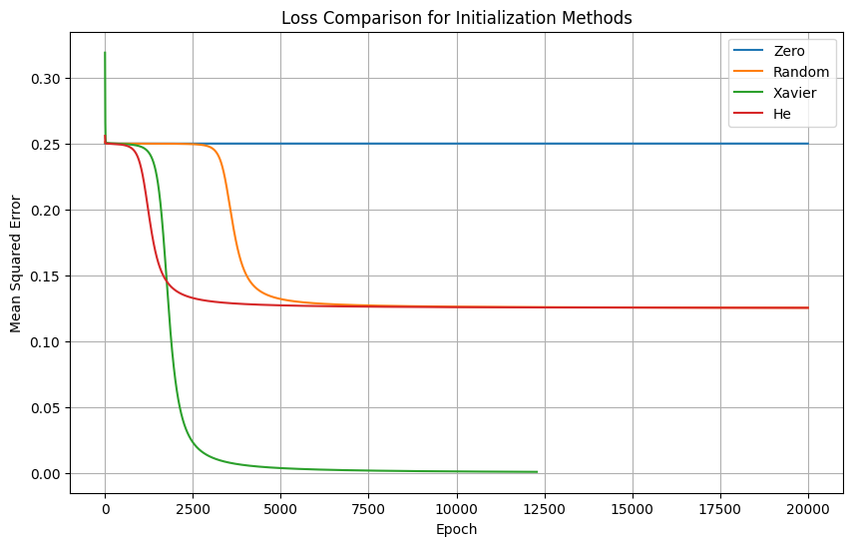
Part J
Final Loss Comparison
Initialization Final Loss
Zero 0.25
Random 0.12545689295232004
Xavier 0.0009999723940255412
He 0.1253963750650607
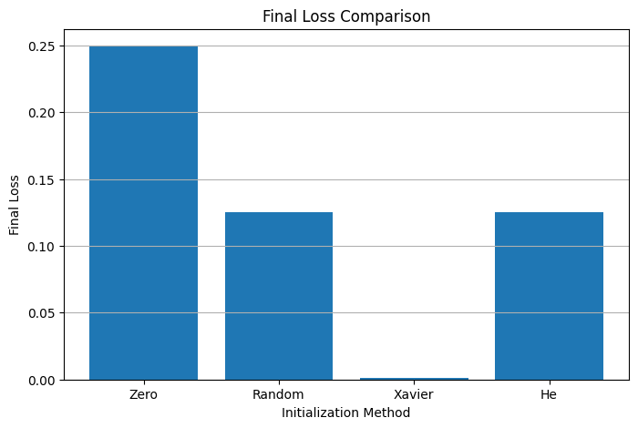
Part K
Epochs to Convergence
Zero epochs: 20000
Random epochs: 20000
Xavier epochs: 12287
He epochs: 20000

Part L
Convergence Table
Initialization Epochs to Convergence Final Loss
Zero 20000 0.25
Random 20000 0.12545689295232004
Xavier 12287 0.0009999723940255412
He 20000 0.1253963750650607
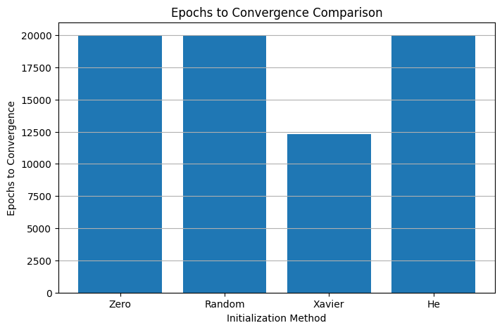
Part M
Final Conclusion
Zero initialization gives identical hidden neuron weights
Identical hidden neurons cause symmetry and prevent useful feature learning
Random initialization breaks the symmetry between hidden neurons
Xavier initialization scales weights according to the input and output sizes
He initialization uses a larger variance suitable for ReLU networks
The same XOR problem can behave differently under different initialization schemes
The loss curves and convergence results show the effect of initialization

